SHRI RAM COLLEGE OF MANAGEMENT,
Muzaffarnagar
Project Report
On
{CHAT SERVER}

Submitted for the partial fulfillment of the

Requirement for the award of

MASTER OF COMPUTER APPLICATION

(2019-2021)

Submitted to: Submitted By:
Mr Sanjaykant Tyagi Harsh Kumar

INDEX

1. INTRODUCTION
  - PURPOSE
  - SCOPE
  - FEATURES
  - OVERVIEW
2. TECHNOLOGY USED
  - FRONT END
  - BACK END
3. REQUIREMENTS
  - SOFTWARE
  - HARDWARE

4. Introduction to Java

5. Snapshots

6. Future Scope

7. Conclusion

8. Coding

9. Bibliography

INTRODUCTION

The client server model is still used today on the internet where a user computing may connect to a service operating on a remote system through the internet protocol suite web browser are clients that connect to web server and retrieve web page for display. Most people use Email client to retrieve their Email from their Internet service provider's mail storage servers. Online Chat uses a variety of clients, which vary depending on the chat protocol being used. Game Clients usually refer to the software that is the game in only multiplayer online games for the computer.
Increasingly, existing large client applications are being switched to websites, making the browser a sort of universal client. This avoids the hassle of downloading a large piece of software onto any computer you want to use the application on. An example of this is the rise of Webmail.

PURPOSE

The objective of the project is to provide an environment to the students that let them chat on an autonomous network systems consisting of Routers, hosts, wireless or LAN network system.

The project is a collection of two distinct but related modules named:

- SERVER
- CLIENT

SCOPE

SERVER

A server computer is a computer dedicated to running a server application. A server application is a Computer program that accepts Computer network connections in order to service requests by sending back responses. Examples of server applications include Mail transfer agent, File server, and Proxy server. Server is also a designation for computer models intended for use in running server applications, often under heavy workloads, unattended, for an extended period of time. While any workstation computer can run server operating systems and server applications, a server computer usually has special features intended to make it more suitable.
These features can include a faster Central processing unit, faster and more plentiful RAM, and larger Hard disk drive, but these traits are shared with high-end Desktop computer. More obvious distinctions include redundancy in power supplies, network connections, and RAID as well as Modular design.
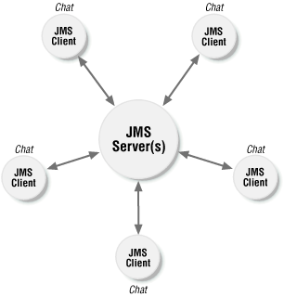
CLIENT

A client is an Application software or system that accesses a remote service on another Computer system, known as a Server computing, by way of a Network. The term was first applied to Peripheral device that were not capable of running their own stand-alone Computer program, but could interact with remote computers via a network. These Dumb terminals were clients of the Time sharing Mainframe computer.

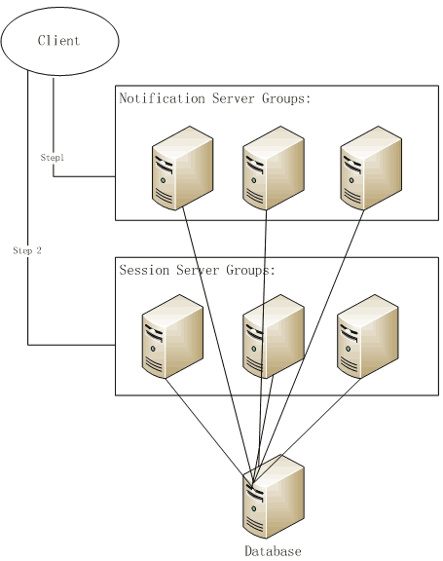
FEATURES

CHARACTERISTICS OF A CLIENT
- Initiates requests
- Waits for and receives replies
- Usually connects to a small number of servers at one time
- Typically interacts directly with end-users using a Graphical user interface

CHARACTERISTICS OF A SERVER

- Never initiates requests or activities
- Listens to network and responds only to requests from connected, authorized clients
- Waits for and replies to requests from connected clients
- A server can remotely install/uninstall applications and transfer data to clients

OVERVIEW

The client-server architecture
The client-server architecture model distinguishes Client (computing) systems from Server (computing) systems, which communicate over a Computer network. A client-server application is a Distributed system comprised of both client and server software. A client software process may initiate a communication session, while the server waits for requests from any client.
Client/server describes the relationship between two computer programs in which one program, the client, makes a service request from another program, the server, which fulfills the request. Although programs within a single computer can use the client/server idea, it is a more important idea in a network. In a network, the client/server model provides a convenient way to efficiently interconnect programs that are distributed across different locations. Computer transactions using the client/server model are very common. Most Internet applications, such as email, web access and database access, are based on the client/server model. For example, a Web browser is a client program at the user computer that may access information at any web server in the world. To check your bank account from your computer, a web browser client program in your computer forwards your request to a web server program at the bank. That program may in turn forward the request to its own database client program that sends a request to a database server at another bank computer to retrieve your account balance. The balance is returned back to the bank database client, which in turn serves it back to the web browser client in your personal computer, which displays the information.

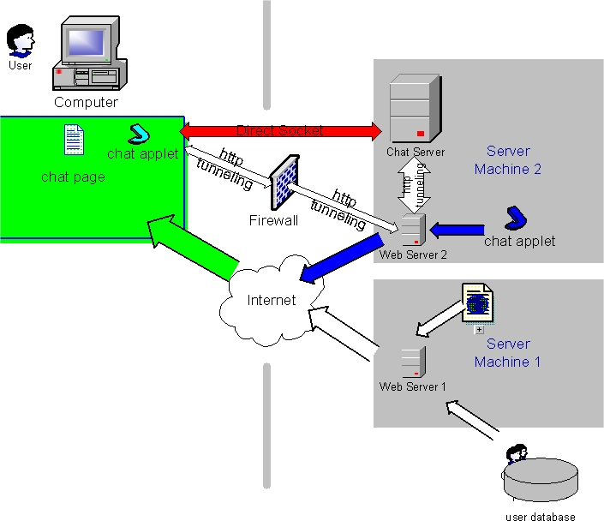

Client-server architecture

Advantages
- In most cases, client-server architecture enables the roles and responsibilities of a computing system to be distributed among several independent computers that are known to each other only through a network. This creates an additional advantage to this architecture: greater ease of maintenance. For example, it is possible to replace, repair, upgrade, or even relocate a server while its clients remain both unaware and unaffected by that change. This independence from change is also referred to as Information hiding.
- All the data is stored on the servers, which generally have far greater security controls than most clients. Servers can better control access and resources, to guarantee that only those clients with the appropriate permissions may access and change data.
- Since data storage is centralized, updates to that data are far easier to administer than what would be possible under a P2P paradigm. Under a P2P architecture, data updates may need to be distributed and applied to each "peer" in the network, which is both time-consuming and error-prone, as there can be thousands or even millions of peers.
- Many mature client-server technologies are already available which were designed to ensure security, 'friendliness' of the user interface, and ease of use.
- It functions with multiple different clients of different capabilities.

Disadvantages
- Traffic congestion on the network has been an issue since the inception of the client-server paradigm. As the number of simultaneous client requests to a given server increases, the server can become severely overloaded. Contrast that to a P2P network, where its bandwidth actually increases as more nodes are added, since the P2P network's overall bandwidth can be roughly computed as the sum of the bandwidths of every node in that network.
- The client-server paradigm lacks the robustness of a good P2P network. Under client-server, should a critical server fail, clients’ requests cannot be fulfilled. In P2P networks, resources are usually distributed among many nodes. Even if one or more nodes depart and abandon a downloading file, for example, the remaining nodes should still have the data needed to complete the download.
Specific types of clients include Web browser, Email client, and Online chat clients.
Specific types of servers include Web server, FTP server, Application Server, Database Server, Mail Server, File Server, Print Server and Terminal Server. Most web services are also types of servers.
FEASIBLITY STUDY
Feasibility is the determination of whether or not a project is worth doing. The process followed in making this determination is called the FEASIBILITY STUDY.
Feasibility study is the test of system , according to its workability, impact on the organization, ability to meet the user needs, and effective use of resources.A feasibility study is conducted to select the best system that meets performance and requirements. Thus this study tells whether the resources which are used would be able to fulfill the requirements of the project, whether the approach used to make the system is suitable enough, whether the prescribed budget is sufficient to meet the needs and whether the system would be able to meet the user’s requirements.
To perform feasibility study basically following question should arises:
- Is there any new and better way to do the job that will benefit the user?
- What are the cost and savings of the alternative?
- Is the prescribed method is flexible or not?
2.2.1 Technical
This is concerned with specifying equipments and soft wares that will successfully satisfy the user’s requirement.
The technical need of the system may include:
(a) The facility to produce output in a given time.
(b) Response time under certain conditions.
(c) Ability to process a certain volume of transaction at a particular speed.
In this feasibility configuration of the system is given minor importance. This configuration
should give the complete picture system requirement.
2.2.2 Behavioral
It determines how much effort and time will go into educating, selling and training the user staff on a candidate system.
2.2.3 Economical
A system developed technically and that will be used if installed must be still profitable for the organization .Financial benefits must equal or exceed the cost.In this feasibility following things are calculated:-
(a) The cost to conduct a full system investigation
(b) The cost of hardware and software.
(c) The cost of checking costly errors.

Feasibility Study for the Project
The Project “INTERNET CHAT” satisfies all the feasibility criteria. The software used are open source software easily available in market. The hardware required to develop this system is a desktop computer with descent computing power.
- In case of financial feasibility, it is quite economical, only hardware circuit requires spending small money.
- In case of administrative feasibility no special training is required for the users as the project is very user-friendly, only working knowledge of computer is required.

TECHNOLOGY USED

Front end - Java

Backend - XML file

REQUIREMENTS

Software Required:

The project is implemented in Core Java and JSP (Java Server Pages) as it provides the implementation of Socket and Server Socket classes that are used to connect distinct applications, hence the software’s required in the creation and execution of the project are j2sdk1.6 or JAVA DEVELOPMENT KIT 6 .As we know JAVA is a platform independent language so this software runs with JRE environment on any desired platform i.e. windows 9x, XP, or 2000 operating system and Apache Tomcat 7.0 as a web server.
Hardware Required:
As the project does not involve any database, its hardware requirements are minimal. Any System with Pentium P2 or above processor, 32MB RAM, 1GB Hard Disk, a LAN Card, and a CDROM is sufficient. Its network based software so computers connected with any kind of mode (wireless, LAN connected etc) will suit its requirements. It can also be run on a single machine for its demo use.
Best suited in laboratory where we can run its server on any machine and many clients can use it simultaneously.
INTRODUCTION TO JAVA
Features
Platform Independent
The concept of Write-once-run-anywhere (known as the Platform independent) is one of the important key feature of java language that makes java as the most powerful language. Not even a single language is idle to this feature but java is closer to this feature. The programs written on one platform can run on any platform provided the platform must have the JVM.
Simple
There are various features that make the java as a simple language. Programs are easy to write and debug because java does not use the pointers explicitly. It is much harder to write the java programs that can crash the system but we can not say about the other programming languages. Java provides the bug free system due to the strong memory management. It also has the automatic memory allocation and de-allocation system.
Object Oriented
To be an Object Oriented language, any language must follow at least the four characteristics.
- Inheritance : It is the process of creating the new classes and using the behavior of the existing classes by extending them just to reuse the existing code and adding the additional features as needed.
- . Encapsulation: It is the mechanism of combining the information and providing the abstraction
- Polymorphism: As the name suggest one name multiple form, Polymorphism is the way of providing the different functionality by the functions having the same name based on the signatures of the methods.
- Dynamic binding: Sometimes we don't have the knowledge of objects about their specific types while writing our code. It is the way of providing the maximum functionality to a program about the specific type at runtime.
As the languages like Objective C, C++ fulfills the above four characteristics yet they are not fully object oriented languages because they are structured as well as object oriented languages. But in case of java, it is a fully Object Oriented language because object is at the outer most level of data structure in java. No stand alone methods, constants, and variables are there in java. Everything in java is object even the primitive data types can also be converted into object by using the wrapper class.
Robust
Java has the strong memory allocation and automatic garbage collection mechanism. It provides the powerful exception handling and type checking mechanism as compare to other programming languages. Compiler checks the program whether there any error and interpreter checks any run time error and makes the system secure from crash. All of the above features makes the java language robust.
Distributed
The widely used protocols like HTTP and FTP are developed in java. Internet programmers can call functions on these protocols and can get access the files from any remote machine on the internet rather than writing codes on their local system.
Portable
The feature Write-once-run-anywhere makes the java language portable provided that the system must have interpreter for the JVM. Java also have the standard data size irrespective of operating system or the processor. These features make the java as a portable language.
Dynamic
While executing the java program the user can get the required files dynamically from a local drive or from a computer thousands of miles away from the user just by connecting with the Internet.
Secure
Java does not use memory pointers explicitly. All the programs in java are run under an area known as the sand box. Security manager determines the accessibility options of a class like reading and writing a file to the local disk. Java uses the public key encryption system to allow the java applications to transmit over the internet in the secure encrypted form. The byte code Verifier checks the classes after loading.
Performance
Java uses native code usage, and lightweight process called threads. In the beginning interpretation of byte code resulted the performance slow but the advance version of JVM uses the adaptive and just in time compilation technique that improves the performance.

Multithreaded.
Java is also a multithreaded programming language. Multithreading means a single program having different threads executing independently at the same time. Multiple threads execute instructions according to the program code in a process or a program. Multithreading works the similar way as multiple processes run on one computer. Multithreading programming is a very interesting concept in Java. In multithreaded programs not even a single thread disturbs the execution of other thread. Threads are obtained from the pool of available ready to run threads and they run on the system CPUs. This is how Multithreading works in Java which you will soon come to know in details in later chapters.

Interpreted
We all know that Java is an interpreted language as well. With an interpreted language such as Java, programs run directly from the source code. The interpreter program reads the source code and translates it on the fly into computations. Thus, Java as an interpreted language depends on an interpreter program.
The versatility of being platform independent makes Java to outshine from other languages. The source code to be written and distributed is platform independent.
Another advantage of Java as an interpreted language is its error debugging quality. Due to this any error occurring in the program gets traced. This is how it is different to work with Java.

Architecture Neutral

The term architectural neutral seems to be weird, but yes Java is an architectural neutral language as well. The growing popularity of networks makes developers think distributed. In the world of network it is essential that the applications must be able to migrate easily to different computer systems. Not only to computer systems but to a wide variety of hardware architecture and operating system architectures as well. The Java compiler does this by generating byte code instructions, to be easily interpreted on any machine and to be easily translated into native machine code on the fly. The compiler generates an architecture-neutral object file format to enable a Java application to execute anywhere on the network and then the compiled code is executed on many processors, given the presence of the Java runtime system. Hence Java was designed to support applications on network. This feature of Java has thrived the programming language.
JDK
The Java Development Kit (JDK) is a Sun Microsystems product aimed at programming
language developers. Since the introduction of Java, it has been by far the most widely used Java Software development kit. On November 17 2006, Sun announced that it would be released under the GNU General Public License (GPL), thus making it Free software. This happened in large part on May 8 2007 and the source code was contributed to the OpenJDK.
The primary components of the JDK are a selection of programming tools, including:
- java – The Loader for Java applications. This tool is an interpreter and can interpret the class files generated by the javac compiler. Now a single launcher is used for both development and deployment. The old deployment launcher, jre, is no longer provided with Sun JDK.
- Javac – The Compiler, which converts source code into bytecode
- jar – The archiver, which packages related class computer class into a single file format. This tool also helps manage JAR files.
- Javadoc– The documentation generator, which automatically generates documentation from source code comments
- jdb – The debugger
- javap – The class file disassembler
- appletviewer – This tool can be used to run and debug Java applets without a web browser.
- javah – The C header and stub generator, used to write native methods

- extcheck – This utility can detect JAR-file conflicts.
- apt – The annotation processing tool
- jhat – (Experimental) Java heap analysis tool
- jstack – (Experimental) This utility prints Java stack traces of Java threads.
- jstat – (Experimental) virtual machine machine statistics monitoring tool
- jstatd – (Experimental) jstat daemon
- jinfo – (Experimental) This utility gets configuration information from a running Java process or crash dump.
- jmap – (Experimental) This utility outputs the memory map for Java and can print shared object memory maps or heap memory details of a given process or core dump.
- idlj – The IDL-to-Java compiler. This utility generates Java bindings from a given IDL file.
- policy tool – The policy creation and management tool, which can determine policy for a Java runtime, specifying which permissions are available for code from various sources
- VisualVM – visual tool integrating several command line JDK tools and lightweight performance and memory profiling capabilities
The JDK also comes with a complete Java Runtime Environment, usually called a private runtime. It consists of a Java Virtual Machine and all of the class libraries that will be present in the production environment, as well as additional libraries only useful to developers, such as the Internationalization and localization libraries and the Interface description language libraries.
Also included are a wide selection of example programs demonstrating the use of almost all portions of the Java API.

Abstract Window Toolkit
The Abstract Window Toolkit (AWT) is Java's original platform-independent windowing, graphics, and user-interface widget toolkit. The AWT is part of the Java Foundation Classes (JFC) — the standard API for providing a graphical user interface (GUI) for a Java program. AWT is also the GUI toolkit for a number of Java ME profiles.
The AWT provides two levels of APIs: A general interface between Java and the native system, used for windowing, events, and layout managers. This API is at the core of Java GUI programming and is also used by Swing and Java 2D. It contains:• The interface between the native windowing system and the Java application;
• The core of the GUI event subsystem;
• Several layout managers;
• The interface to input devices such as mouse and keyboard; and
• A java.awt.datatransfer package for use with the Clipboard and Drag and Drop.
A basic set of GUI widgets such as buttons, text boxes, and menus. It also provides the AWT Native Interface, which enables rendering libraries compiled to native code to draw directly to an AWT Canvas object drawing surface.
AWT also makes some higher level functionalityavailable to applications, such as:
• Access to the system tray on supporting systems; and Java application.
Neither AWT nor Swing are inherently thread safe. Therefore, code that updates the GUI or processes events should execute on the Event dispatching thread. Failure to do so may result in a deadlock or race condition. To address this problem, a utility class called SwingWorker allows applications to perform time-consuming tasks following user-interaction events in the event dispatching thread.

FORM DESIGN
Database File

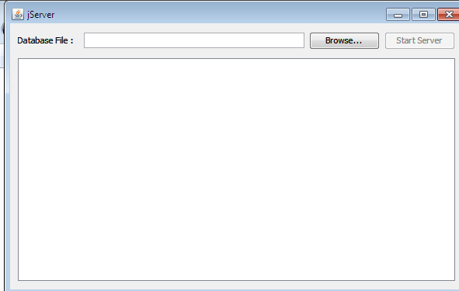

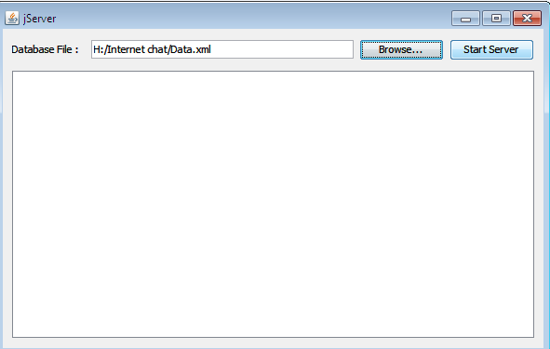
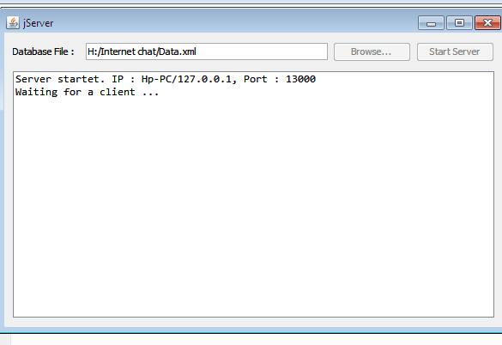

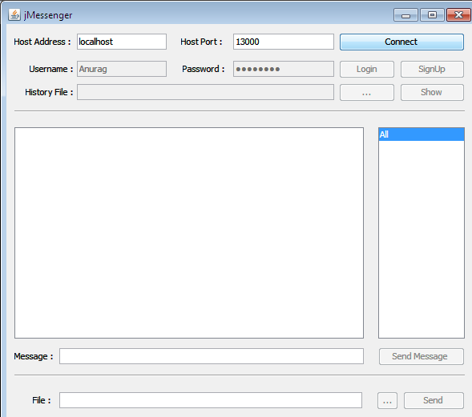+

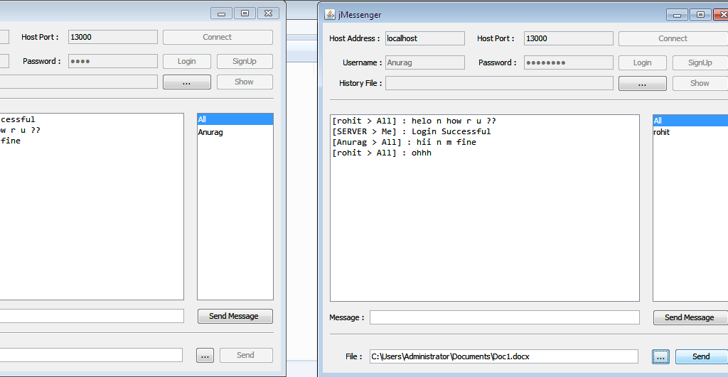

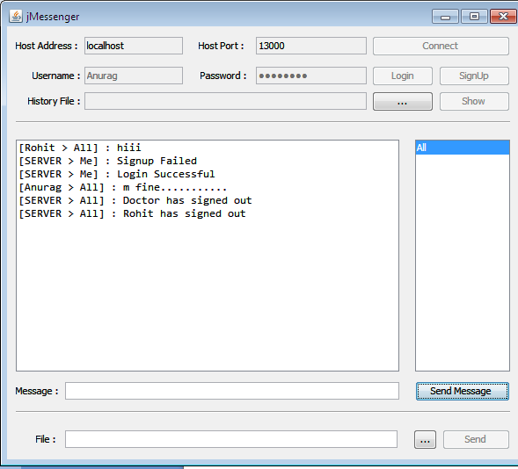
BIBLOGRAPHY

- Complete Ref.
Author Harbert Sheil
Publisher TataMcGraw-Hil
Black Book of java

- Microsoft Office

- Software Engineering Apractitioner’s Approach
Author Roger S. Pressman
Publication Tata McGraw-Hill

- Fundamentals of Software Engineering
Author Carlo Ghezzi, Mehdi Jazayeri, DinoMandrioli
Publisher Prentice Hall of India

